Ecommerce Order Fulfillment and Delivery Performance Analysis

1.Introduction:

An e-commerce company processes hundreds of orders daily across different regions and product categories. However, increasing delivery delays are impacting customer satisfaction and operational efficiency.

This project focuses on analyzing order fulfilment performance by tracking delivery timelines, delayed shipments, regional distribution, and sales contribution. The goal is to monitor delivery efficiency, identify delay patterns, and support data-driven improvements in logistics operations.

2.Problem Statement
The company lacks a centralized monitoring system to track delivery performance and identify delay trends across regions and product categories.
Without structured analysis:
- Delivery delays go unnoticed.
- Regional performance differences are unclear.
- Average delivery time is not monitored.
- Sales impact due to delays cannot be measured.
A dashboard solution is required to track order fulfilment performance and reduce delays.

3.Dataset Description
The dataset used for this project contains transactional order-level data that helps analyze delivery performance, regional sales distribution, and operational efficiency. Each row represents a single customer order.
It includes the following columns:
- Order ID – A unique identifier for each order, used to track and analyze individual transactions.
- Order Date – The date on which the customer placed the order. This is used for time-based analysis such as monthly order trends.
- Delivery Date – The date on which the order was delivered to the customer. It helps measure delivery performance.
- Delivery Status – Indicates whether the order was delivered On-Time or Delayed. This is used to monitor logistics efficiency.
- Region – Represents the geographical area where the order was delivered. It enables region-wise performance comparison.
- Product Category – Specifies the category of product purchased (e.g., Fashion, Electronics, Books, Home). Used for category-wise sales and delay analysis.
- Sales Amount – The revenue generated from each order. This helps evaluate overall business performance and category contribution.
This structured dataset enables analysis across multiple dimensions such as time, region, product category, and delivery efficiency making it suitable for building an interactive order fulfilment dashboard.

4.Tools Used
1.BasicExcel
Used for initial data gathering and inspection, such as opening CSV files, understanding data structure, checking column names, and performing basic filtering and sorting before detailed analysis.
2.Python
Used as the primary programming language for data processing and analysis.
3.Pandas
Used for data cleaning, transformation, and manipulation, including handling missing values, correcting inconsistent data, filtering records, and preparing datasets for analysis.
4.NumPy
Used for numerical operations and calculations, such as performing mathematical computations, aggregations.
5.PowerBI
Used to build an interactive dashboard with KPI cards, charts, slicers, and DAX measures to monitor order fulfilment performance and delivery efficiency.

5.Data cleaning and Preprocessing
Data cleaning and preprocessing were performed using Python (Pandas and NumPy) to ensure data accuracy, consistency, and reliability before building the dashboard.
The following steps were carried out:
- First, the CSV file was imported into Python using Pandas to inspect the dataset structure, column names, and data types.
- Next, duplicate records were checked to ensure that no order was counted more than once. Any duplicate entries identified were reviewed and removed to maintain data integrity.
- The Order Date and Delivery Date columns were converted into datetime format. This step was necessary to enable time-based analysis and calculate delivery duration accurately.
- A new column was created by extracting the month from the Order Date. This helped in performing monthly trend analysis in the dashboard.
- To measure operational efficiency, delivery duration was calculated by finding the difference between Delivery Date and Order Date in days. This allowed the computation of average delivery time and delay analysis.
- Data validation was also performed to ensure logical consistency. Orders where the Delivery Date was earlier than the Order Date were identified and flagged as invalid records. This step ensured that only logically correct transactions were used for analysis.
- Additionally, a binary indicator column was created to represent delayed orders (1 for delayed, 0 for on-time). This simplified delay percentage calculation in Power BI using aggregation functions.
These preprocessing steps ensured that the dataset was clean, logically valid, and fully prepared for accurate analysis and dashboard development.

6.Power BI Dashboard
After completing data cleaning and preprocessing, the prepared dataset was imported into Power BI to design an interactive and performance-focused Order Fulfilment Dashboard.
The dashboard was developed to provide a comprehensive view of order delivery performance, regional sales distribution, and operational efficiency. It enables management to quickly monitor delays, identify trends, and make data-driven decisions to improve delivery performance.
KPI Cards
The top section of the dashboard contains key performance indicators (KPIs) that provide a quick summary of business performance:
- Total Sales – Displays the overall revenue generated from all orders.
- Total Orders – Shows the total number of orders placed.
- Average Delivery Days – Represents the average time taken to deliver orders.
- Total On-Time Orders – Indicates the number of orders delivered within the expected timeframe.
- Total Delayed Orders – Shows the number of orders delivered late.
These KPIs provide an instant snapshot of operational efficiency and delivery performance.
Visualizations Included
1.Sales by Category (Column Chart)
This visual compares total sales across different product categories such as Fashion, Electronics, Books, and Home.
It helps identify which categories generate higher revenue and whether certain categories experience more delays.
2. Delayed vs On-Time Orders (Pie Chart)
This chart displays the proportion of delayed and on-time orders.
It helps evaluate overall delivery efficiency and highlights the percentage of orders affected by delays.
3. Regional Sales Distribution by Category (Stacked Column Chart)
This visual shows sales contribution by region along with category breakdown.
It enables comparison of regional performance and helps identify areas where delays or sales performance may require attention.
4. Orders Received by Month (Line Chart)
This chart shows monthly order trends.
It helps identify seasonal demand patterns and fluctuations in order volume, which may impact delivery performance.
5. Summary Table
The detailed table displays order-level information including:
- Order ID
- Product Category
- Order Date
- Delivery Date
- Delivery Status
This allows users to drill down into specific transactions and verify delivery timelines.

Filters and Slicers
Interactive slicers are included to enhance dashboard usability:
- Product Category
- Region
- Order Date Range
- Delivery Date Range
- Delivery Status(Delayed or On-Time)
These filters allow users to dynamically analyze specific segments of data and gain customized insights.

10.DAX Measures Used
DAX (Data Analysis Expressions) was used in Power BI to calculate key performance metrics required to evaluate order fulfilment efficiency and overall business performance. The following measures were created:
Total Orders
This measure calculates the total number of unique orders placed.
- Total Orders = DISTINCTCOUNT(Orders[Order ID])
Total Sales
This measure calculates the overall revenue generated from all orders.
- Total Sales = SUM(Orders[Sales Amount])
It helps evaluate the financial performance of the business.
Total Delayed Orders
This measure calculates the total number of delayed deliveries.
- Total Delayed Orders = SUM(Orders[Is_Delayed])
It helps measure delivery inefficiency.
Total On-Time Orders
This measure calculates the total number of orders delivered on time.
- Total On-Time Orders =
CALCULATE(
COUNT(Orders[Order ID]),
Orders[Delivery Status] = "On-Time")
It helps monitor delivery performance and operational reliability.
Average Delivery Days
This measure calculates the average number of days taken to deliver an order.
- AVERAGE(Orders[Delivery_Duration_In_Days])
It provides insight into overall logistics efficiency.

7.Conclusion
The E-Commerce Order Fulfilment Dashboard successfully analyzes order delivery performance, regional sales contribution, and operational efficiency using structured data preprocessing and interactive Power BI visualization.
Through calculated KPIs such as Total Orders, Total Sales, Total Delayed Orders, Total On-Time Orders, and Average Delivery Days, the dashboard provides a clear overview of fulfilment performance. It helps identify delivery delays, monitor average shipping time, and compare performance across regions and product categories.
The analysis highlights areas where delivery efficiency can be improved and enables the company to take corrective actions in logistics planning and resource allocation. By transforming raw transactional data into meaningful insights, the dashboard supports data-driven decision-making and enhances overall customer satisfaction.
Overall, this project demonstrates how business intelligence tools can be effectively used to monitor operational performance and improve order fulfilment processes.

8.Dashboard Photos

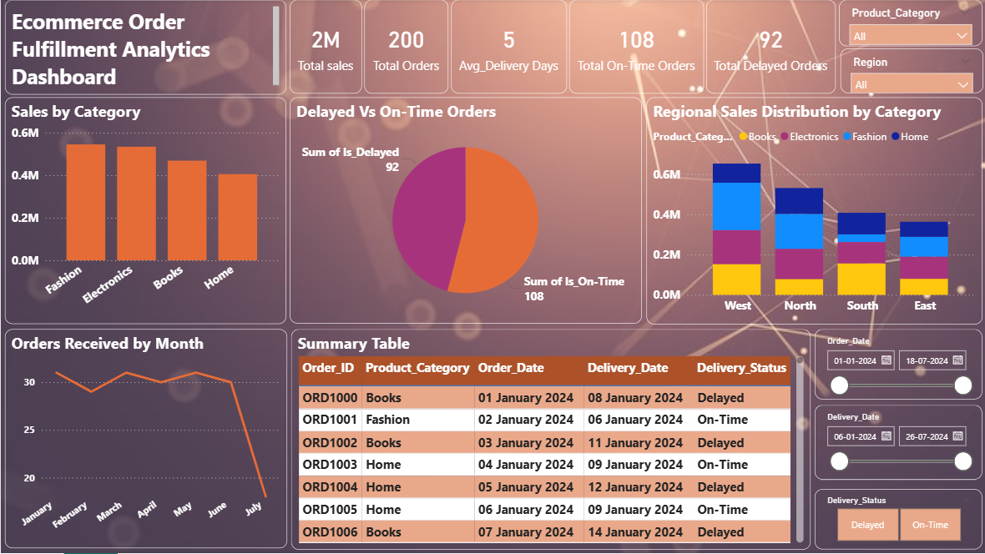
Submitted By:Dnyaneshwari Pawar

